Cover letter

What did you set out to accomplish in this revision? Do you feel you succeeded?
In this revision I strived to organize my ideas and make my writing as concise as possible because that is one thing I struggle with. I had so much to say, and not enough time to add everything I wanted to this essay. However, I feel good about the organizational changes I made to my paper and believe that it helps to broaden the scope of what I am covering in this final draft. I feel that I tried my best and I’m proud of what I have written.
How did your thesis or motive change? Please explain. Note: you must show change or development of your thesis since the draft. My final thesis does not differ greatly from my original thesis. I changed the wording slightly. I added that this commercial shows women as willing participants in their objectification. I changed the order of my words in my motive to make it more direct. My original motive was “Male and female insecurities are exploited in
many television and print ads, manipulating viewers into feeling that that a certain product is
essential for them to become the glamorized version of themselves, while also perpetuating
harmful societal roles.” My new motive is more direct language. It is “Advertisers exploit the insecurities of men and women in television and print, creating the impression that they need to buy, own, and use a given product in order to become the glamorized version of themselves, while also perpetuating harmful societal roles.” It uses the active voice.
What steps or stages did you go through in your revision process?
First, I read my essay aloud and corrected grammar and spelling errors. Then, I had my friend read it so see if they thought my paper made sense and proved my argument. After my consultation, I went through my essay while looking at your revisions and worked to reorganize my essay to improve its flow and to help say more about my topic.
Did you use the Writing Center? If so, please describe your experience.
I went to the workshop on close reading papers but personally did not find it helpful.
Comment on the pre-draft, peer review process, and your conference with the instructor. Were these helpful to you? What could have been done to improve them? The peer review process helped me understand what I needed to do to make my whole concept more put together and less vague. The conference was most helpful because it helped me see what I needed to change as well as what I’d done well. It helped me see flaws in my writing that I was consistently overlooked. I think it would have been more helpful if we had the commented-on drafts sooner after turning in the drafts.
Other Comments?
I had a lot of fun writing this essay. I found the assignment really interesting and look forward to showing people my thoughts.

Claire Kiewra
Douglas Kirshen
UWS: Sex and Advertising
October 11th, 2018
“Sexist Snacks”
People may not realize it, but advertising plays a large part in how members of society view themselves and others. Commercials have a strange power over the world as they both use and create societal roles, especially when concerning issues of the sexes. Advertisers exploit the insecurities of men and women in television and print, creating the impression that they need to buy, own, and use a given product in order to become the glamorized version of themselves, while also perpetuating harmful societal roles. The 1998 television commercial for Doritos 3Ds portrays its male consumers as inferior and disheveled young men accustomed to hitting on women from the sidelines. It also creates a fantasy world through sound and lighting effects in which these men feel empowered to objectify women by perpetuating harmful images of female sexuality as a commodity that women actively and willingly put on display for men.
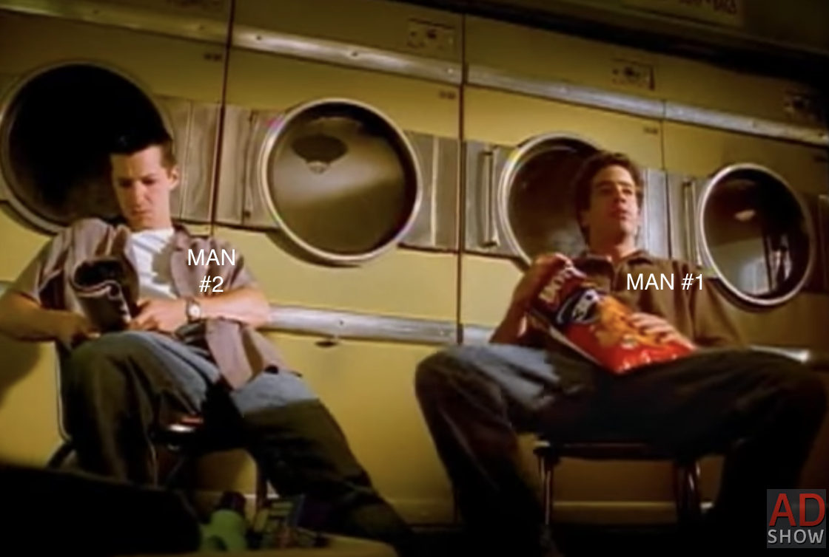
Dorito’s 60-second commercial targets insecure men by portraying their male customers as losers who struggle to win the attention of attractive women, showing that men are seen as inferior. The two men in the ad, Man #1 and Man #2 are first shown slumped back in their chairs in front of two dryers. Along with their abysmal posture, the two men wear in ill-fitting, wrinkly clothes. Though the men are doing laundry, it is clear from their general appearance that these men do not pay attention to their image. They are sloppy and scruffy, with no real care for the impression they make to the world. They are not the typical men that women would be drawn to. Male viewers, perhaps slouched on the couch eating a bag of Doritos, will recognize themselves in these men, subconsciously reminded that they present themselves just as Men #1 and #2 do. Dorito’s portrayal of men travels further down the path of loserdom when a woman enters the laundromat. 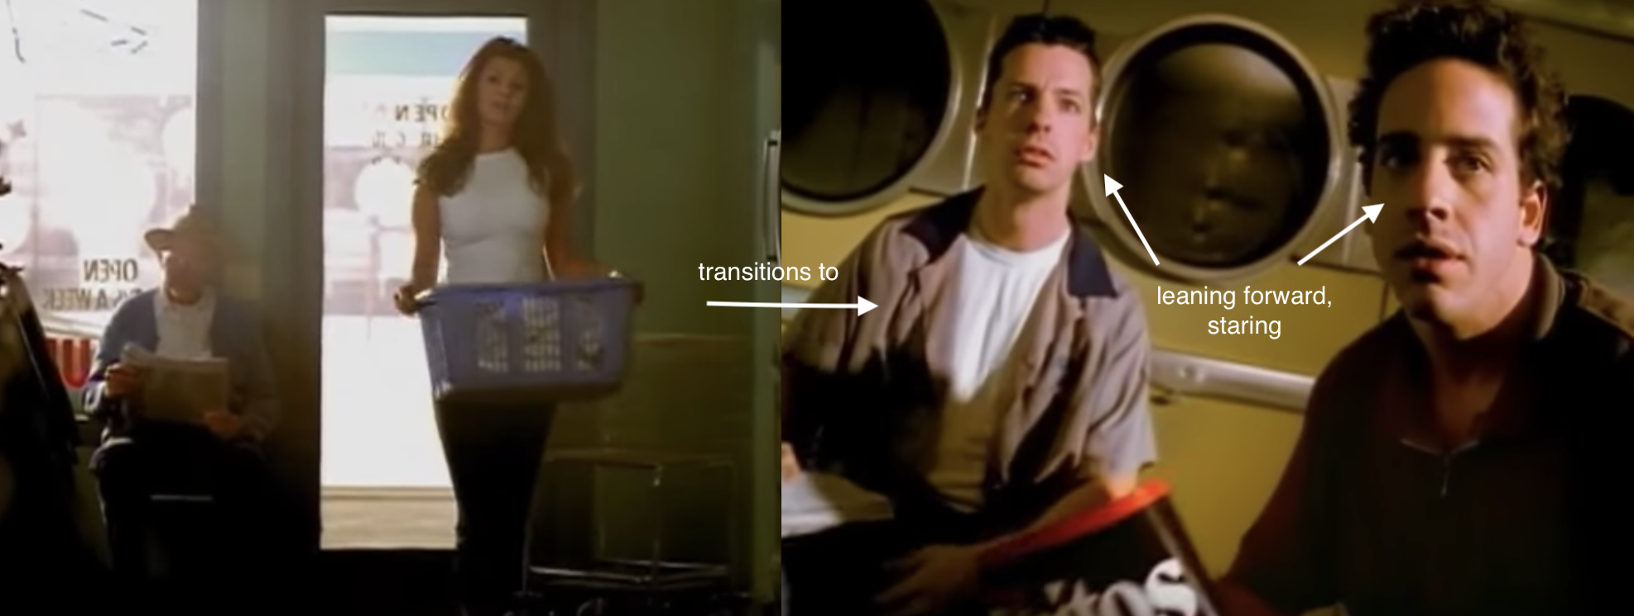
Immediately after The Woman’s entrance, there is a shot of the men leaning forward, seemingly shocked and enchanted. We, the viewers, are then shown several cuts of the men, then The Woman, and then the men again. The stark contrast between the beautiful, sleek woman and the two scruffy men highlights the social inferiority of the average loser-type male. The levels the director uses in his blocking also illustrate the inadequacy of this type of man. Man #1 and Man #2 are sitting while gazing at The Woman from afar, she stands at a washing machine, quite literally looking down at them. Though she looks at her admirers flirtatiously, she is still, and always will be, above them. 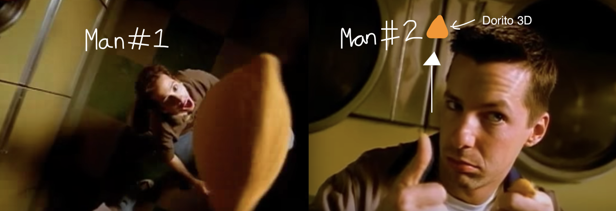

Man #1 and #2 try to impress The Woman by throwing Doritos in the air and catching them in their mouths and though this seems to entertain The Woman, she soon reveals her own tricks. At the climax of the commercial, The Woman begins to execute tricks far more elaborate than the men’s while snapping the Doritos out of the air as they fly towards her. The men watch in awe as she flips and spins, ending with a split on the laundromat floor. Like her appearance and demeanor, The Woman’s eating tricks are on a much higher level than her male counterparts’, further cementing Man#1 and Man #2’s inferiority.
When she leaves, The Woman flashes a condescending smirk to the men. Despite showing off for the men watching her, The Woman knows that she will always rank above them and shows her haughtiness as she exits.

Successfully manipulating viewers with the loser-male-narrative relies on the viewers relating to the commercial. Doritos creates this relationship effectively by exhibiting common human experiences. The Woman’s entrance into the commercial is a distinct moment. Suddenly, there is a women in Man #1 and Man #2’s presence: a woman who is there for their viewing. A tight shot of Man #2 following The Woman’s entrance shows his wide, almost hungry eyes and features a very pronounced “gulp.”
The immediate, intense reaction to a beautiful woman’s presence lets audiences see this as a special moment. These men are not used to being around beautiful women. The following close-up shot forces the viewer to focus on Man #1’s distress and makes the viewer experience that anxiety with him. This segment will bring emotions and experiences to the front of male viewers’ minds; it is very likely that they have experienced something similar. Also, the Sound effects used in the commercial are over-the-top, and cartoonish. When the two men try to impress The Woman with their Doritos tricks, the sound effects are akin to those in cartoons these men grew up watching, for example, Wacky Races. The campiness of sounds attached to a simple act like eating further removes the commercial’s world from reality. Male viewers sense that this is a place where they are comfortable and where they can thrive. Also, like in video games, men have some degree of control, especially over the women. Thus, male viewers will not feel targeted by Dorito’s portrayal of them, they will feel a connection.
Though Doritos portrays the men in the ad as losers, the commercial uses lighting and music to create a fantasy scenario in which even loser men can get a hot woman’s attention. The commercial begins with a slow camera pan over a laundromat. The audience hears a jaunty tune whose rhythm will quickly get stuck in one’s mind. The music’s pattern is simple, the same “bum ba dum ba” cycle repeating mirrors music used in video games and cartoons from the 90s. Not only does this create a feeling of familiarity, but it also brings the customer out of the real world and into the laundromat where magical women appear and entertain you.
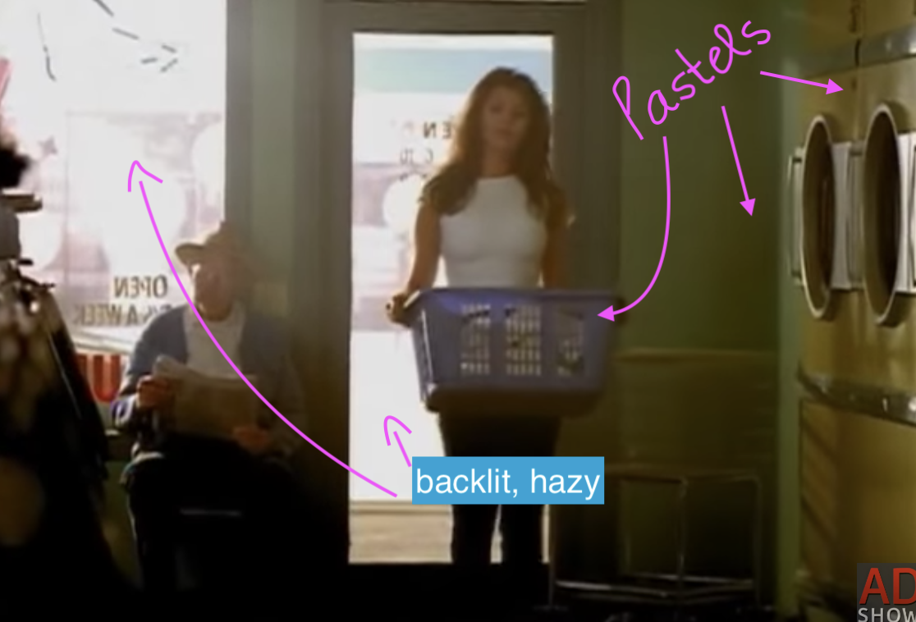
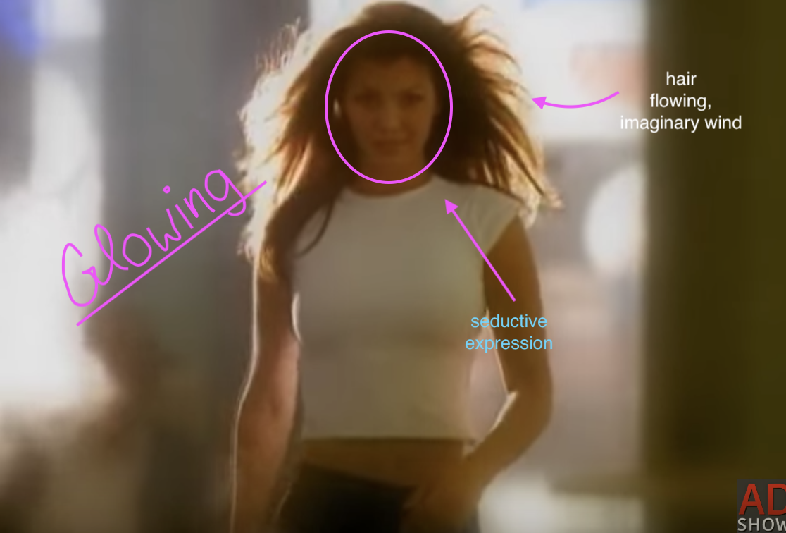
Also, the atmosphere of the commercial is very hazy, creating a daydream-like atmosphere. The light is soft and yellow, and windows make the laundromat bright. A bright and foggy feeling softens the situation to a point where it becomes believable.When The Woman walks in, she is surrounded by light. The backlighting creates a halo effect. Making The Woman appear as some magical, glowing creature makes her less threatening to viewers and even more desirable. There is a lack of reality that helps men watching distance themselves from their own experiences, while still connecting with the men in the commercial. Male viewers can see the women they have wanted in the past and present but feel that they may have a chance at getting her attention because she is a part of the fantasy constructed by the commercial.
The fantasy world surrounding The Woman expands as she makes her way towards Man #1 and Man #2, towards the camera. The previously quick-paced editing style transitions to a slow-motion shot of The Woman walking, hair blowing behind her, still glowing. Many people have imagined a movie-like slow-motion moment, and Doritos is making it happen. In their fantasy world, these events seen in TV and movies can happen in real life, even to losers. If these men buy and eat Doritos, this fantasy world will become a reality. In this fantasy world, these “losers” do not have to face the reality of rejection. Instead, there is a feeling that the world of Doritos 3Ds is one that is built for them.
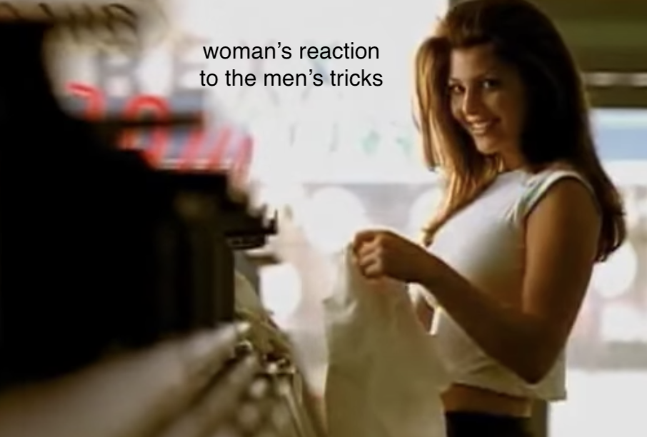
Perhaps the most dangerous aspect of this Doritos advertisement is the fact that it portrays women as objects that are happy to be controlled and taken advantage of by men.
The men get The Woman’s attention by dramatically and loudly eating their Doritos 3Ds, playing with their food. Though not immediately smitten, The Woman does give the men her attention. Here, men are shown how their immature antics can have a positive impact on women. The way Man #1 and Man #2 play with their food while eating it mirrors the way men tend to play with women’s emotions, not caring about the consequences as they see women as nothing more than objects from which to obtain pleasure. Some of the only spoken words in the commercial is a voiceover of a man saying “Doritos 3Ds, a whole new shape that begs to be eaten… In very loud ways.” This voice over takes place while The Woman is doing her tricks with the chips, putting them in the dryer before eating them out of the air. These words equate women to food. Women are something fun and new for men to consume. Using the word “begs” is key in showing viewers that women want men to treat them this way. They are pleading men to consume them. The slogan's wording cultivates a victim-blaming mindset in male watchers who are subliminally taught that viewing women as consumable goods is something that women deserve and also want. The notion that women enjoy being objectified is enforced by the words “in very loud ways.” This phrase alludes to a woman showing her enjoyment during sex by being very vocal about that enjoyment. One common insecurity amongst men is their ability to please their female partners in bed. Doritos’ commercial assures them that if they eat Doritos 3Ds, women will always be easily satisfied and impressed. The climax of the commercial is when The Woman performs for the men, one-upping them on all of their “tricks” by executing impressive jumps and flips.
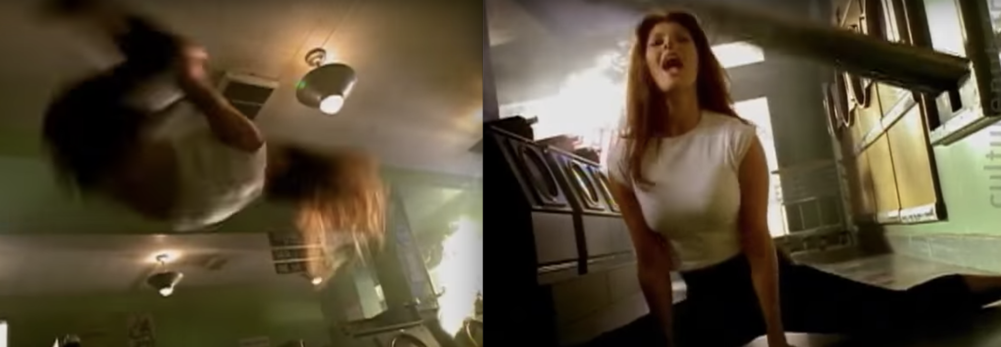
She performs these acts with a look of elation and pride on her face as Man #1 and #2 gawk shamelessly at the spectacle. In the commercial's world, women enjoy being an object in the male gaze, even thriving because of it.
Women's representation in the media affects their lives both individually and as a collective group. Commercials have one goal: to sell products. However, in doing their job, advertisements can harm people. Grown men watch a commercial similar to the Doritos 3Ds commercial discussed in this essay strengthening their learned misogyny. Boys and girls who see these kinds of images in their formative years experience the same effects as the adults, often to a greater extent as their developing worldviews meet the commercial’s influence. Young boys may see an ad such as this one and, without realizing the implications of what they are watching, learn to see women as objects or playthings. Young girls look at these advertisements and discover that they are meant to accept their role as men’s entertainment. Both men and women are affected by these sexist commercials; we must be aware of what media we are consuming.

Bibliography
Doritos. Advertisement. 1998 super bowl XXXII commercials. Television.
https://adland.tv/commercials/doritos-3ds-ali-landry-laundromat-1998-060-usa

